To freeze the dynamic element

Go to developer tool Ctrl+shift+i

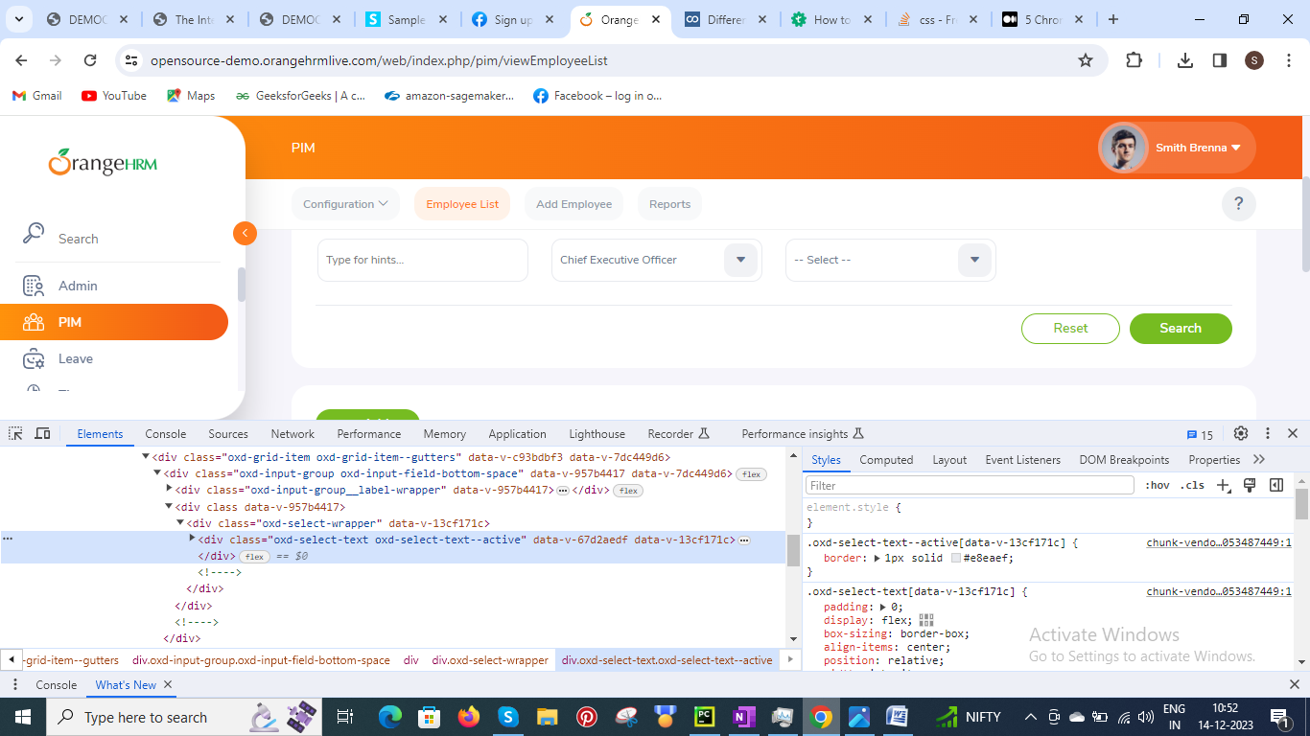

Click on sources tab

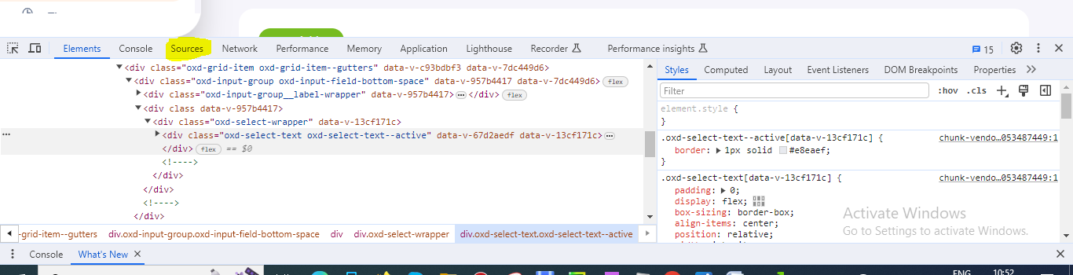

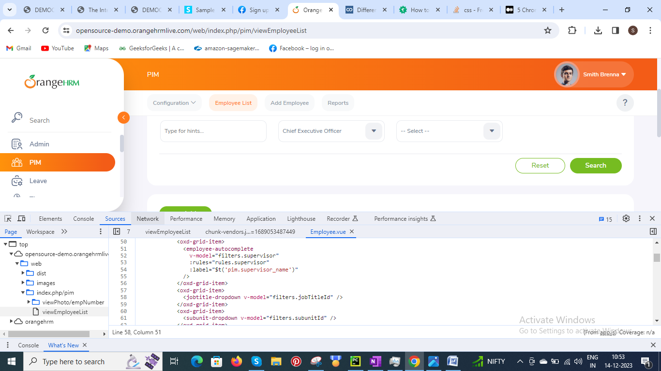

Click show debugger icon (right side)

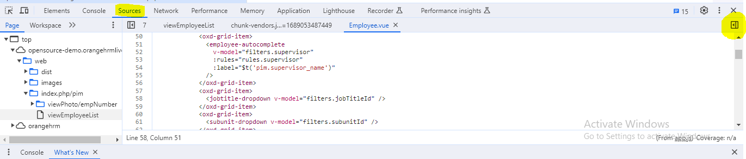

Click Event listener breakpoints

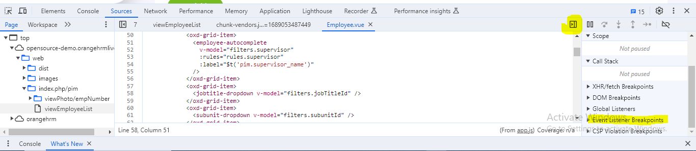

Click Mouse

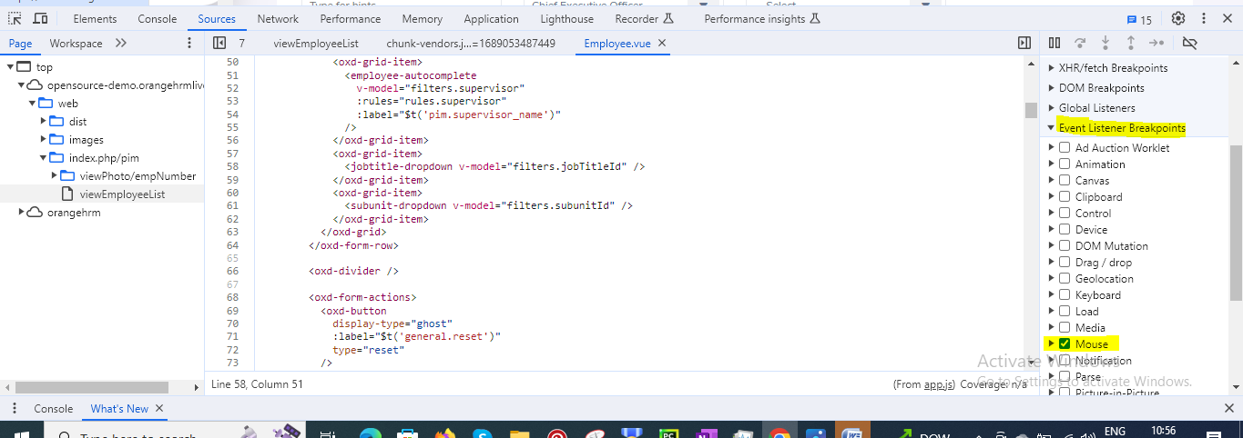

Now click on pause screen execution icon (||)

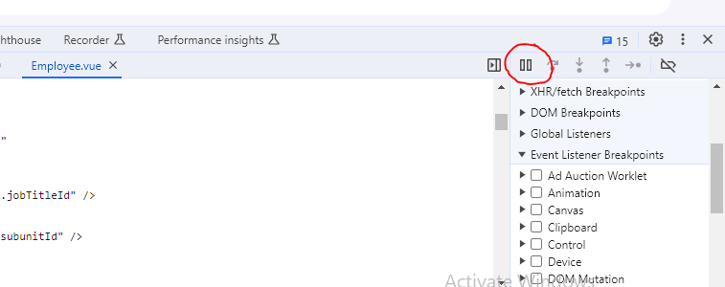

Now right click on the element to freeze

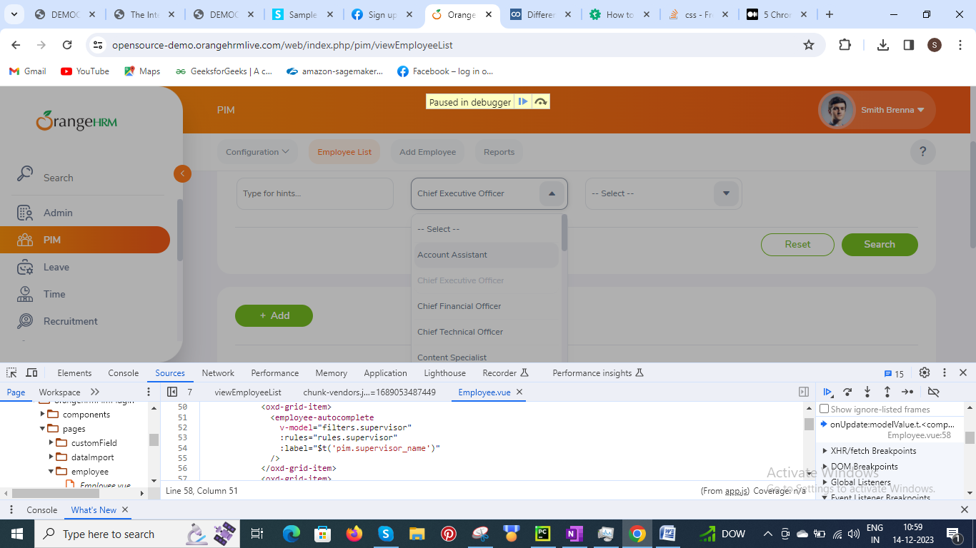

Now go to element tab and click on path you need to inspect

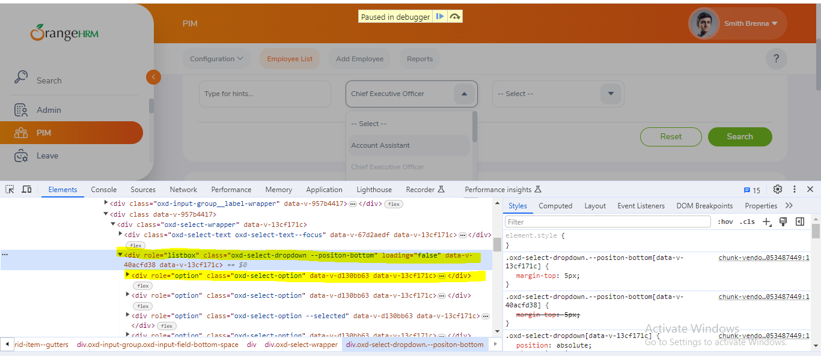

**Tips to freeze or get autosuggestions:**

Control+\ or F8 pause the java exe

Go to event listeners-> look for 'blur' option -> click remove remove all property(works for auto selection)

Go to event listeners-> look for 'mouseout' option -> click remove remove all property(works for tooltip)